Installation
Manual
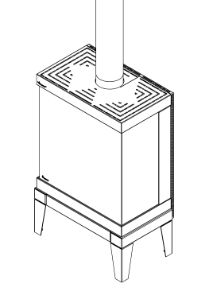

Nancy | Sharp

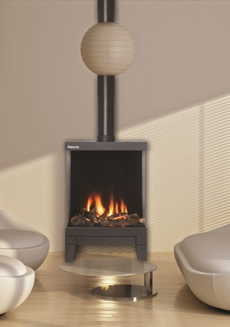 | 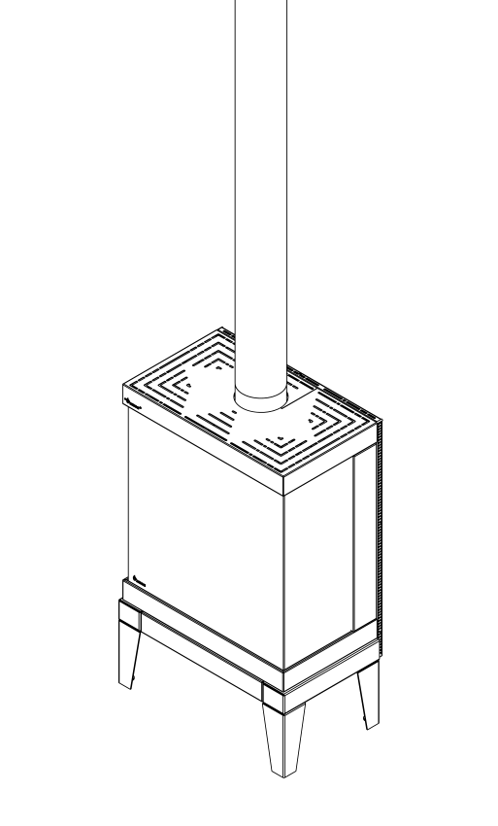
1.1 | 1.2
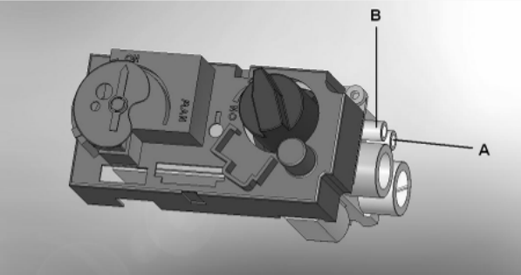

1.3
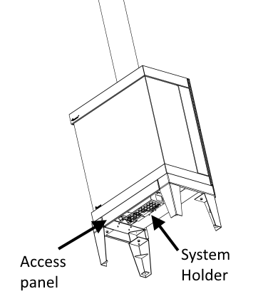

1.4

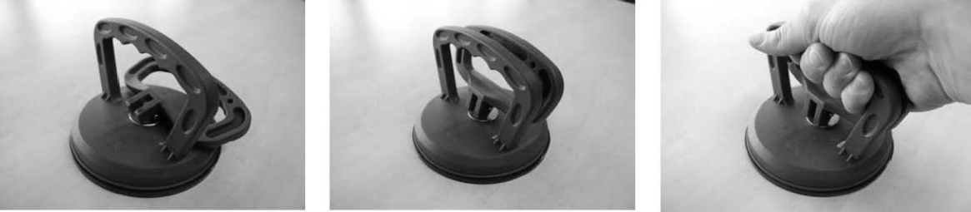

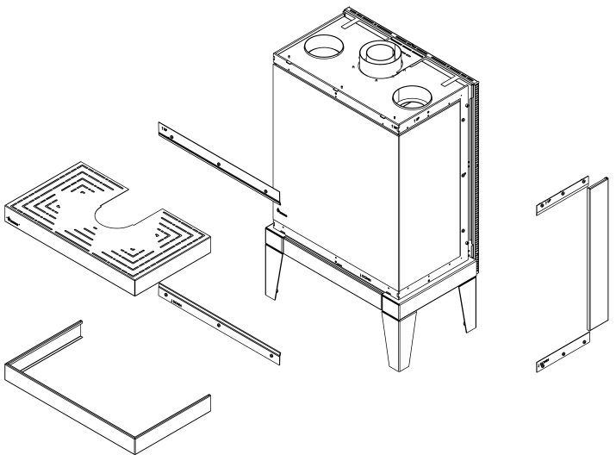  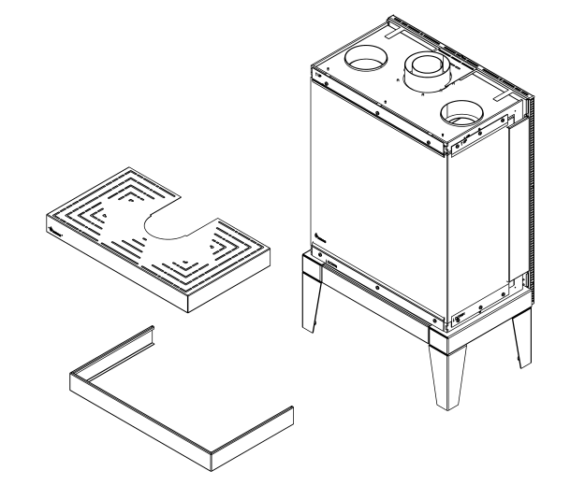 | A
2-1 | 2-2
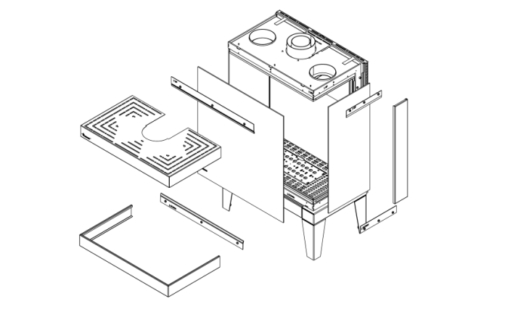 | 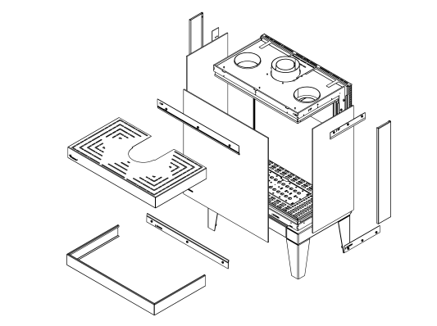
2-3 | 2-4

3-3

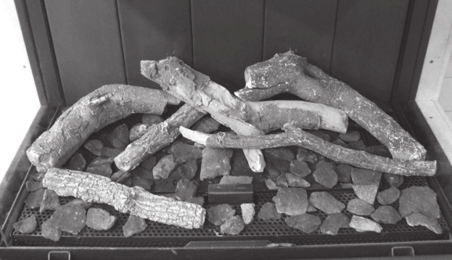

3.1

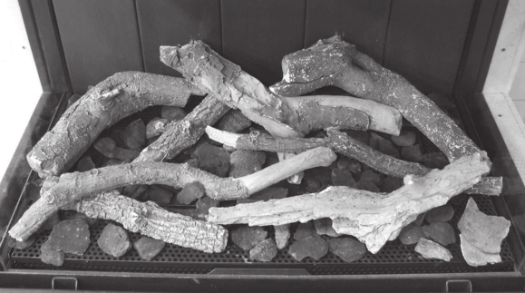

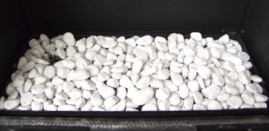
3.2

Contents
1 Introduction 8
2 Safety instructions. 8
3 Installation requirements 9
3.1 The fire 9
3.2 False Chimney breast 9
3.3 Requirements flue system and outlets 9
3.4 Terminals 10
3.5 Existing chimney 10
4 Preparation and Installation instructions 11
4.1 Gas connection 11
4.2 Electric connection 11
4.3 Preparation of the appliance 11
4.4 Placing the appliance 11
4.5 Mounting the smoke emission outlet materials 12
4.6 Building a false chimney breast. 12
4.7 Chimney breast 12
4.8 Frameless 12
5 Removing the glass 13
6 Placing the decorative material 13
6.1 Imitation logs 13
6.2 Pebbles 13
7 Checking the installation. 14
7.1 Checking the ignition of the pilot burner, main burner. 14
7.2 Checking for gas leakage. 14
7.3 Checking the burner pressure and the pre-pressure 14
7.4 Checking the flame picture. 15
8 Instructing the client 15
9 Annual maintenance 16
9.1 Service and cleaning: 16
9.2 Replace: 16
9.3 Cleaning the glass 16
10 Conversion to a different type of gas (e.g. propane) 16
11 Calculation of flue system 17
11.1 Points of particular interest: 17
11.2 Sample computations 18
12 Table 19
13 Technical data 20
14 Dimension of the appliance 21
FS-3S / Sharp 21
FS-370 / Nancy 21

1 Introduction

The appliance can only be installed by a competent person in accordance with the Gas

Safety. We urgently advise you to read this installation manual properly.

This appliance complies with the guidelines for European gas appliances (Gas Appliances

Directive) and bears the CE mark.

2 Safety instructions.

• The appliance should be placed, connected and annually checked in accordance with these installation instructions and valid national and local Gas Safety
(Installation and Use) Regulations .

• Check whether the data on the registration plate are in agreement with the local type of domestic gas and pressure.

• The fitter is not permitted to change these adjustments or the construction of the appliance!

• Do not place any additional imitation logs or glowing coals on the burner or in the combustion chamber.
• The appliance has been designed for ambience and heating purposes. This means that all surfaces of the appliance , including the glass, can become very hot (hotter
than 100 °C). An exception to this are the bottom of the appliance and the controls.
• Do not place any inflammable materials within a of 0.5 m. of the radiation of the appliance and ventilation grills.
• Due to natural air circulation of the appliance, moisture and volatile components from paint, building materials, floor coverings etc. that haven’t yet set, can be
drawn through the convection system and can be deposited on cold surfaces as soot. That is why you should not use the appliance shortly after a renovation.
• The first time the appliance is switched on, Let the fire run on maximum setting for several hours so that the lacquer coating will have an opportunity to set and
possible vapours released can be safely removed by ventilation. We advise you to be outside the room as much as possible during this process!
• Please note that:
1 all transport packaging should be removed.

2 children or pets should not be present in the room.

3 Installation requirements

3.1 The fire

• The appliance must be built into an existing or a newly to be constructed false chimney breast.
• In the freestand models the gas control valve and the receiver are mounted behind the access panel in the system holder (fig. 1.4). Flip over the access panel in order to gain access to the system.

3.2 False Chimney breast

• The false chimney breast must be constructed of an non-combustible material.
• Always ventilate the space above the appliance by means of the grills or a comparable alternative with a minimum air supply of 200 cm².
• For the finish, use special stucco (min. 100°C resistant) or glass fibre wallpaper to prevent discoloration or cracks etc. Recommended drying time: for plaster is a
minimum of 24 hours per mm of coat applied.

• The false chimney breast and its construction may not rest on the appliance

3.3 Requirements flue system and outlets

• You should always make use of the materials prescribed by Carmel Heating Ltd.
Only by using these materials can Carmel Heating Ltd. guarantee a proper functioning.
• The outside of the concentric flue material can reach a temperature of
Approx 150°C. Make sure of proper insulation and protection in case of transit through combustible wall or ceiling constructions. And observe sufficient distance.
• Make sure that the concentric flue materials are bracketed every 2 meters when they have an extended length, so that the weight of the flue material is not resting
on the appliance itself.

• You may never start with a cut-down concentric pipe directly on to the appliance.

3.4 Terminals

The flue outlet can end on an external wall or a roof . Check whether the outlet desired by you complies with local requirements concerning good function and ventilation systems .
For a proper functioning the terminal should be at least 0.5 m. away from:

• Corners of the building.
• Roof overhangs and balconies.
• Eaves (with the exception of the roof ridge).

3.5 Existing chimney

You can also connect the appliance to an existing chimney. The existing chimney will function as an air supply and a flexible stainless steel pipe drawn up through the chimney will remove the combustion gas.
The flexible stainless steel pipe of Ø 100 mm should have a CE mark for temperatures up to

600° Celsius.

The chimney should comply with the following requirements:

• The diameter of the flue system must be at least 150x150 mm.
• There should be no more than 1 appliance connected to a flue pipe.
• The chimney must be in good condition
o No leakage and

o It should be properly swept.

For more information about connections to existing flue systems, see the manual

“connections”.

4 Preparation and Installation instructions

4.1 Gas connection

The gas connection must comply with locally valid standards.

We advise Pipe work from the meter to the appliance must be of adequate size., with near the appliance a gas isolater tap that should always be accessible. Place the gas connection in such a way that this is easily accessible, and that before service, the burner unit can be disconnected at all times.

4.2 Electric connection

If an adapter is used for the power supply, then a wall socket 230VAC – 50Hz must be mounted in the close neighbourhood of the hearth.

4.3 Preparation of the appliance

• Remove the packaging of the appliance . Make sure the gas pipes underneath the appliance are not damaged.
• Clear a safe space to store the glass.
• Remove the glass and take the separately wrapped parts out of the appliance
• Prepare the gas connection to the gas control valve.

4.4 Placing the appliance

Take the installation requirements into account (see chapter3)

Place the appliance into the proper position and if necessary, adjust the height with the adjustable legs.
To level the hearth with a spirit level – level the hearth with rotating, adjustable legs.

•

4.5 Mounting the smoke emission outlet materials

• In case of a wall or roof terminal, the hole must be at least 5 mm bigger than the diameter of the flue material.
• Horizontal parts must be installed at a (3 degree) slope up away the appliance.
• Build up the system from the appliance. If this is not possible, you should make use of a adjustable pipe .
• For fitting the system a ½ metre cut-down pipe should be used. Make sure the inner pipe is always 2 cm longer than the outer pipe. Wall and roof terminal are
also shortened. These parts must be secured with a self tapping screw.

• Do not insulate but ventilate bild-in flue material (approx.100cm2)

4.6 Building a false chimney breast.

Before constructing the false chimney breast we advise you to perform a function test with the gas hearth as described in chapter 7 “checking the installation”

4.7 Chimney breast

• Construct the false chimney breast from non- combustible sheet metal in combination with metal profiles or of brickwork / aerated concrete bricks.
• Take the grates and the service panel (see fig. 1.1 and1.2 )into account. Place a protective shield made of non- combustible material above the grates (see
fig.1.1A) .

• Always use a lintel if the chimney breast is constructed of brickwork. These should not be placed directly onto the appliance.

4.8 Frameless

• Construct the chimney breast against the build-in frame.
Keep a minimum margin of 3 mm between chimney breast and the appliance in connection with the expansion of the appliance.
• The depth of the recess has no influence on the removal of the glass.

5 Removing the glass

- Remove the top and bottom and side covers. (see fig. 2.1
- Remove the glass holding strip on the top. (see fig. 2.2 )
- Slightly loosen the bolts on the bottom strip.
- Place the suction discs onto the glass.
- Slide the glass gently upwards, using the suction disks, until it is removed. (fig. 2.3)
- Repeat steps 2 to 5 for side glass. (fig. 2.4)

To replace the glass repeat the process in reverse order.

Remove all Fingerprints from the glass, these will be burned into it once the hearth is used.

6 Placing the decorative material

It is not allowed to add different or more materials to the combustion chamber. Always keep the pilot burner free from decorative material!
Do not toss all the decorative material onto the burner all at once, it can be obstructed by dust particles.

6.1 Imitation logs

• Place a number of the chips onto the burner and on the cover plate
• Place the imitation logs according to instructions. (see fig. 3.1/ 3.2 or imitation logs instruction card supplied)
• Divide the remainder of the chips over the burner and the cover plate . Avoid a thick layer onto the burner, this has a negative effect on the fire image.
• Ignite the pilot and main burner according to the instructions in the user’s manual.
Assess whether the flame division is correct. If necessary, move the chips until there is a proper division of flames.
• Place the glass and check the fire image.

6.2 Pebbles

• Place the pebbles on the burner and the cover plate (see fig. 3.3 or imitation logs instruction card supplied). Avoid a double layer; this has a negative effect on the
fire image.

• Place the glass and check the fire image.

7 Checking the installation.

7.1 Checking the ignition of the pilot burner, main burner.

Start the pilot and main burner according to the instructions in the user’s manual.

• Check whether the pilot light is properly positioned above the main burner and is not covered by chips, an imitation log or pebbles.
• Check the ignition of the main burner at full mark or low mark. (the ignition should take place quickly and easily).

7.2 Checking for gas leakage.

Check all connections and joins for possible gas leaks by means of a gas leak detector or spray

7.3 Checking the burner pressure and the pre-pressure

Check whether the burner pressure and the inlet pressure measured agree with the data indicated on the registration plate

Measuring the inlet-pressure:

• Turn off the gas control tap.
• Open the pressure gauge nipple B (see fig. 1.3) a few turns and connect a pressure gauge hose to the gas control valve.
• Carry out this measurement when the appliance is on at full gas mark and when it is on the pilot light.
• If the inlet pressure is too high you are not permitted to connect the appliance.

Measuring the burner pressure:

Only perform this measurement if the inlet-pressure is correct.

• Open the pressure gauge nipple A (see fig.1.3) a few turns and connect a pressure
gauge hose to the gas control valve.

• The pressure must agree with the value indicated on the registration plate. In case of deviations, get in touch with the manufacturer.

* Close the pressure gauge nipples and check these for gas leaks.

7.4 Checking the flame picture.

Allow the applaince to burn for at least 20 minutes at full and then check the flame picture for:
1. Distribution of the flames

2. Colour of the flames

If either one or both points are unacceptable, then check:

• The positioning of the imitation logs and/or the quantity of pebbles or chips on the burner.
• The connections of the Flue materials for leakage (in case of blue flames)
• Whether the correct flue restrictor has been mounted
• The outlet .
o Wall terminal is installed correctly

o Roof terminal is fitted and sited correctly

• The flue system is correctly calculated

8 Instructing the client

• Recommend that the appliance be serviced annually by a competent person in order to guarantee a safe use and a long lifespan.
• Advise and instruct the client about maintenance and cleaning of the glass.
Emphasize the risk of burning in fingerprints.
• Instruct the client about the operation of the appliance and the remote control unit, including the replacement of the batteries and adjusting the receiver for initial use.

• Hand over to the client:

o Installation manual

o User’s manual

o Imitation logs instruction card

o Suction lifters

9 Annual maintenance

9.1 Service and cleaning:

• Check and clean if necessary after checking:
o The pilot light

o The burner (in an LPG flat burner replace the burner sheet)

o The combustion chamber

o The glass

o The logs for possible fractures

o The outlet

9.2 Replace:

o (in an LPG flat burner replace the burner sheet)

o If necessary the chips/embers.

9.3 Cleaning the glass

Most of the deposits can be removed with a dry cloth. You can use ceramic hob cleaner to clean the glass.
Note: prevent fingerprints on the glass. these will be burned into it once the appliance is

used and cannot be removed anymore!

Carry-out the check-up according to the instructions in chapter 7 “checking the installation”

10 Conversion to a different type of gas (e.g. propane)
This can only be done by installing the proper burner unit. for this purpose get in touch

with your supplier.

Always mention the type and serial number of the appliance when ordering.

11 Calculation of flue system

The possibilities for the lengths of flue pipes and the possible restrictors have been recorded in a table (see chapter 12 ) This table works with a vertical and a horizontal length.

• To define the vertical length all lengths of flue pipes in a vertical direction should be added up.
- The roof terminal always counts as 1 metre.

• To define the horizontal length all lengths of flue pipes in a horizontal direction should be added up.
- every 90° bend in the horizontal part counts as 2 metres.

- every 45° bend in the horizontal part counts as 1 metre.

- Turns from vertical to horizontal or vice versa are not reckoned in the calculation.
- The wall terminal always counts as 1 metre.

If there is transit under 45° then the real vertical and horizontal lengths should be calculated.

11.1 Points of particular interest:

- The maximum chimney length is 12 meters.
- You can never start with a 90° or 45° bend from the appliance.
- You should always start with 1 meter vertical if the horizontal transit is more than 1 meter.
- You should never start with a cut-down pipe from the appliance.

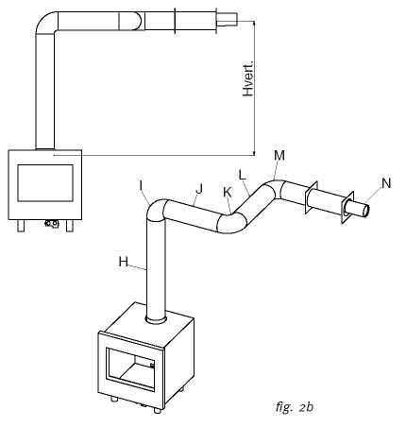

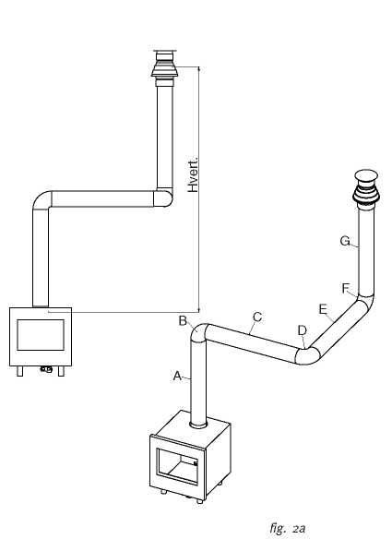

11.2 Sample computations

Sample calculation 1

Count the horizontal lengths

Flue pipe lengths | C+E = 1 + 1 | 2 m
Bend | D = 1 x 2 m | 2 m
Total |  | 4 m

Count the vertical lengths
Flue pipe length A | 1 m
Roof terminal G |  | 1 m
Total | 2 m

Sample calculation 2

Count the horizontal lengths

Flue pipe lengths J + L = 0,5 + 0,5 1 m Bends K+ M = 2 + 2 m 4 m Wall terminal 1 m Total horizontal length 6 m

Count the vertical lengths

Flue pipe length H 1 m

Total 1m

12 Table

Find the correct vertical and horizontal lengths in the table.

In case of an “x”, or if the values are outside the table, the combination is not permitted. The value found indicates the width of the restrictor to be placed ("0" means no restrictor should be placed).
Generally a 30mm restrictor is pre-installed

 |  | Horizontal
 |  | 0 | 1 | 2 | 3 | 4 | 5 | 6
Verticaal | 0 | x | x | x | x | x | x | x
 | 0.5 | x | x | x | x | x | x | x
 | 1 | 0 | 0 | 0 | x | x | x | X
 | 1.5 | 30 | 30 | 0 | 0 | x | x | X
 | 2 | 30 | 30 | 30 | 0 | 0 | 0 | 0
 | 3 | 40 | 30 | 30 | 30 | 0 | 0 | 0
 | 4 | 40 | 40 | 30 | 30 | 30 | 0 | 0
 | 5 | 50 | 40 | 40 | 30 | 30 | 30 | 0
 | 6 | 50 | 50 | 40 | 40 | 30 | 30 | 0
 | 7 | 50 | 50 | 50 | 40 | 40 | 40 | x
 | 8 | 60 | 50 | 50 | 40 | 40 | x | x
 | 9 | 60 | 60 | 50 | 50 | x | x | x
 | 10 | 65 | 60 | 60 | x | x | x | x
 | 11 | 65 | 65 | x | x | x | x | x
 | 12 | 65 | x | x | x | x | x | x

13 Technical data

Gas category |  | II 2H3+ | II 2H3+ | II 2H3+
Type of appliance |  | C11/ C31 | C11/ C31 | C11/ C31
Reference gas |  | G20 | G30 | G31
Input Nett | kW | 11 | 11 | 10.6
Efficiency class |  | 2 | 2 | 2
NOx class
inlet-pressure | mbar | 20 | 30 | 37
Gas rate at 15ºC and 1013 mbar | l/h | - | 357 | -
Gas rate at 15ºC and 1013 mbar | gr/h | - | 900 | -
Burner pressure at full mark | mbar | 10 | 23 | 28.6
Injector main burner | mm | 1.1 | 1.1 | 1.1
Reduced input restraint | mm | - | - | -
Pilot assembly |  | Mertic | Mertic | Mertic
Code Injector |  | - | - | -
Flue size | mm | 100/150 | 100/150 | 100/150
Gas control valve |  | GV60 | GV60 | GV60
Gas connection |  | 3/8” | 3/8” | 3/8”
Electrical connection | V | 220 | 220 | 220
Batteries receiver | V | AA 4x | AA 4x | AA 4x
Batteries sender | V | 9 | 9 | 9

14 Dimension of the appliance

FS-3S / Sharp
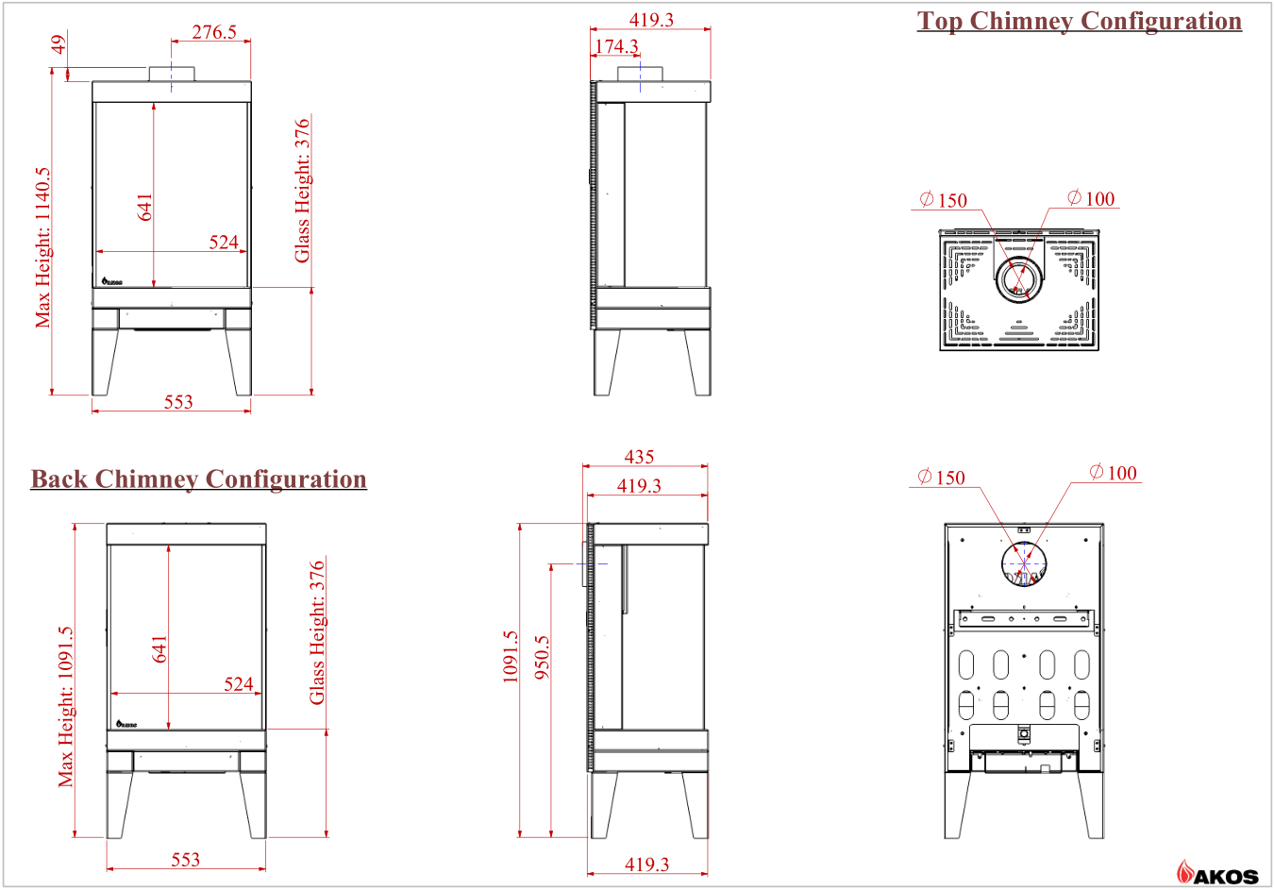

FS-370 / Nancy
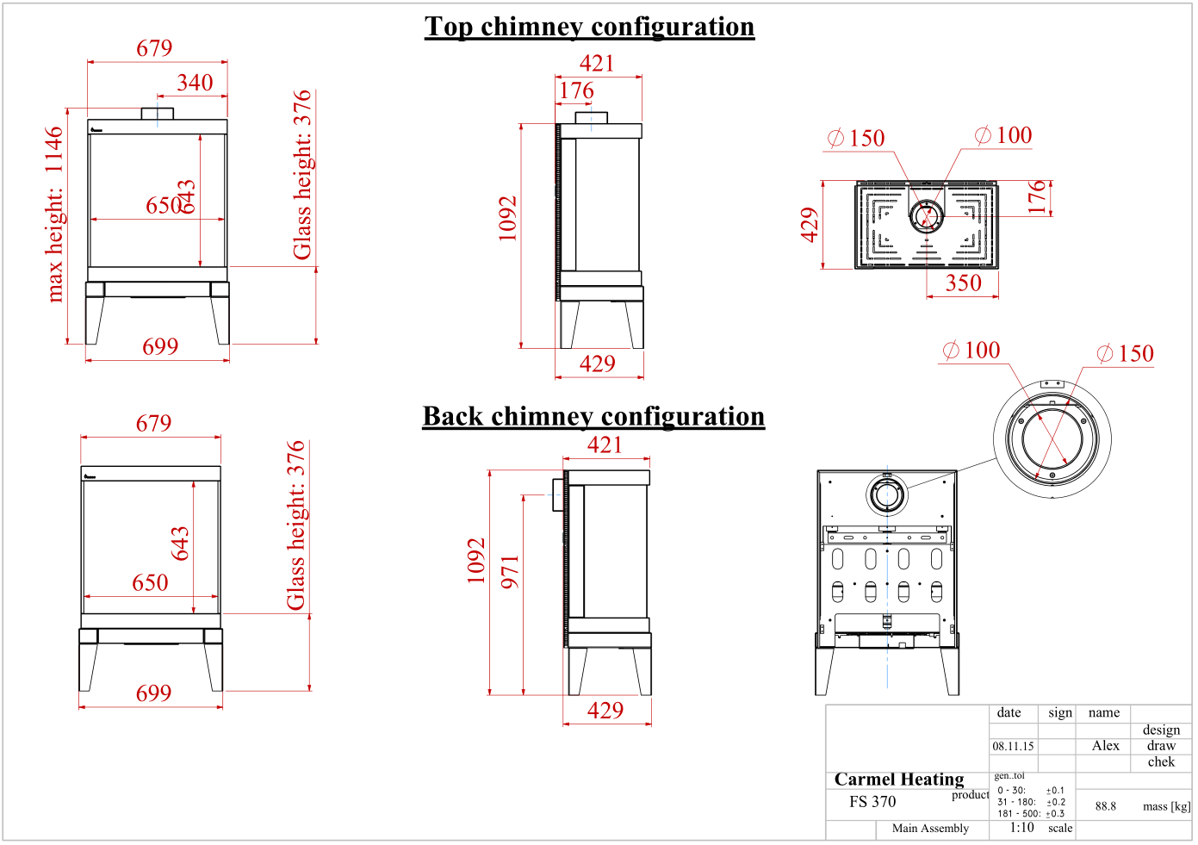

www.akos.co.il
akos@bezeqin.net
Mota Gur 7, Petah Tikva, Israel

